**PRACTICAL 1**

**Objective**

WAP to implement DFS and BFS for traversing a graph from source node (S) to goal node (G), where source node and goal node is given by the user as an input.

**Program**

from collections import deque

import timeit

*def calculate_distance_bfs(graph, path, state, end):*

visited = set()

distance = 0

count = 0

while state != end:

for key in list((graph[state]).keys()):

if key not in visited:

distance = distance + graph[state][key]

visited.add(key)

if key == end:

break

if key == end:

break

count = count + 1

state = path[count]

return distance

*def tsp_bfs(graph, start, end):*

visited = set()

path = []

distance = 0

queue = deque([start])

visited.add(start)

while queue:

vertex = queue.popleft()

path.append(vertex)

if vertex == end:

distance = calculate_distance_bfs(graph, path, start, end)

return path, distance

for adj in graph[vertex]:

if adj not in visited:

visited.add(adj)

queue.append(adj)

return path, distance

*def calculate_distance_dfs(graph, path):*

distance = 0

for i in range(len(path) - 1):

distance += graph[path[i]][path[i + 1]]

return distance

*def tsp_dfs(graph, start, stop):*

visited = set()

stack = [start]

path = []

distance = 0

while stack:

vertex = stack.pop()

path.append(vertex)

visited.add(vertex)

if vertex == stop:

distance = calculate_distance_dfs(graph, path)

return path, distance

temp_stack = []

for adj in graph[vertex]:

if adj not in visited:

temp_stack.append(adj)

stack.extend(temp_stack[::-1])

return path, distance

*if __name__ == "__main__":*

graph_1 = {

"A": {"B": 22, "C": 48, "D": 28},

"B": {"A": 22, "C": 20, "D": 18},

"C": {"A": 48, "B": 20, "D": 32},

"D": {"A": 28, "B": 18, "C": 32},

}

graph_2 = {

"A": {"B": 2, "G": 6},

"B": {"A": 2, "C": 7, "E": 2},

"C": {"B": 7, "D": 3, "F": 3},

"D": {"C": 3, "H": 2},

"E": {"B": 2, "F": 2, "G": 1},

"F": {"C": 3, "E": 2, "H": 2},

"G": {"A": 6, "E": 1, "H": 4},

"H": {"D": 2, "F": 2, "G": 4},

}

start = input("Enter the starting node: ")

end = input("Enter the ending node: ")

***# DFS***

start_time_dfs = timeit.default_timer()

path, dist = tsp_dfs(graph_2, start, end)

execution_time_dfs = timeit.default_timer() - start_time_dfs

***# BFS***

start_time_bfs = timeit.default_timer()

path, dist = tsp_bfs(graph_2, start, end)

execution_time_bfs = timeit.default_timer() - start_time_bfs

print("\nDFS Path:", "".join(path))

print("DFS Cost:", dist)

print("DFS Execution Time:", execution_time_dfs)

print("\nBFS Path:", "".join(path))

print("BFS Cost:", dist)

print("BFS Execution Time:", execution_time_bfs)

**Output**

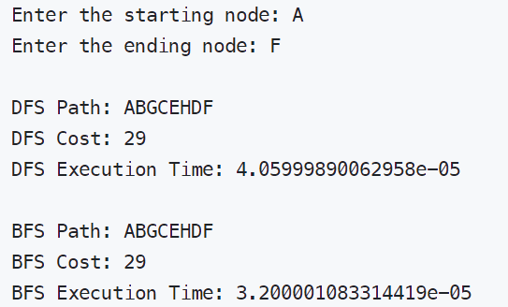

**Results**

According to the results the **DFS** traversing **takes more time** than **BFS** traversing. Hence in the given example BFS outperforms DFS.